**Purpose**

To establish an operation procedure for the Faxitron Path Specimen Radiography System including safe usage, maintenance, and cleaning of the Faxitron unit. Everyone who operates the Faxitron must read this document, perform a walk through with a trained PA and sign the acknowledgment binder.

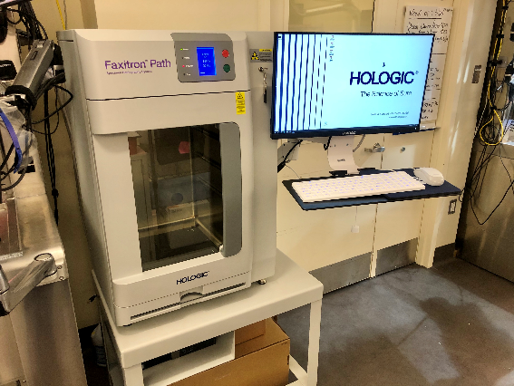

**Procedure**

**Power-up sequence:**

* Be sure the switch at the back of the Faxitron Path cabinet is set to the **On** position.
* Turn the key on the front of the Faxitron Path cabinet to **On**.
* Turn on the computer and monitor.
* The software should automatically initialize once the computer is turned on and the desktop screen appears—this may take a few minutes.

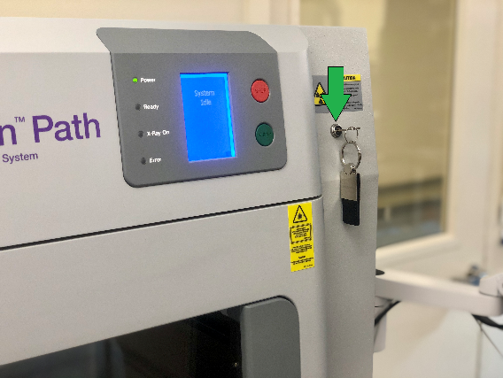 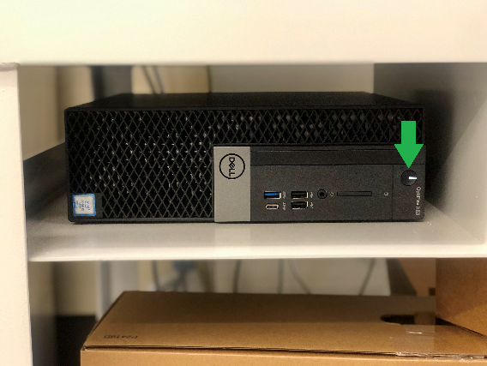

**Start Software:**

* Double click on the **Faxitron Vision Icon**.
* Verify that there is nothing in the Faxitron Path x-ray chamber.
* Allow the system to run through automatic calibration.

**Calibrate:** A designated PA will calibrate the machine every Monday.

* Press the **Calibrate** button to calibrate the machine.

**Patient Data:**

* Click **Start Procedure**.

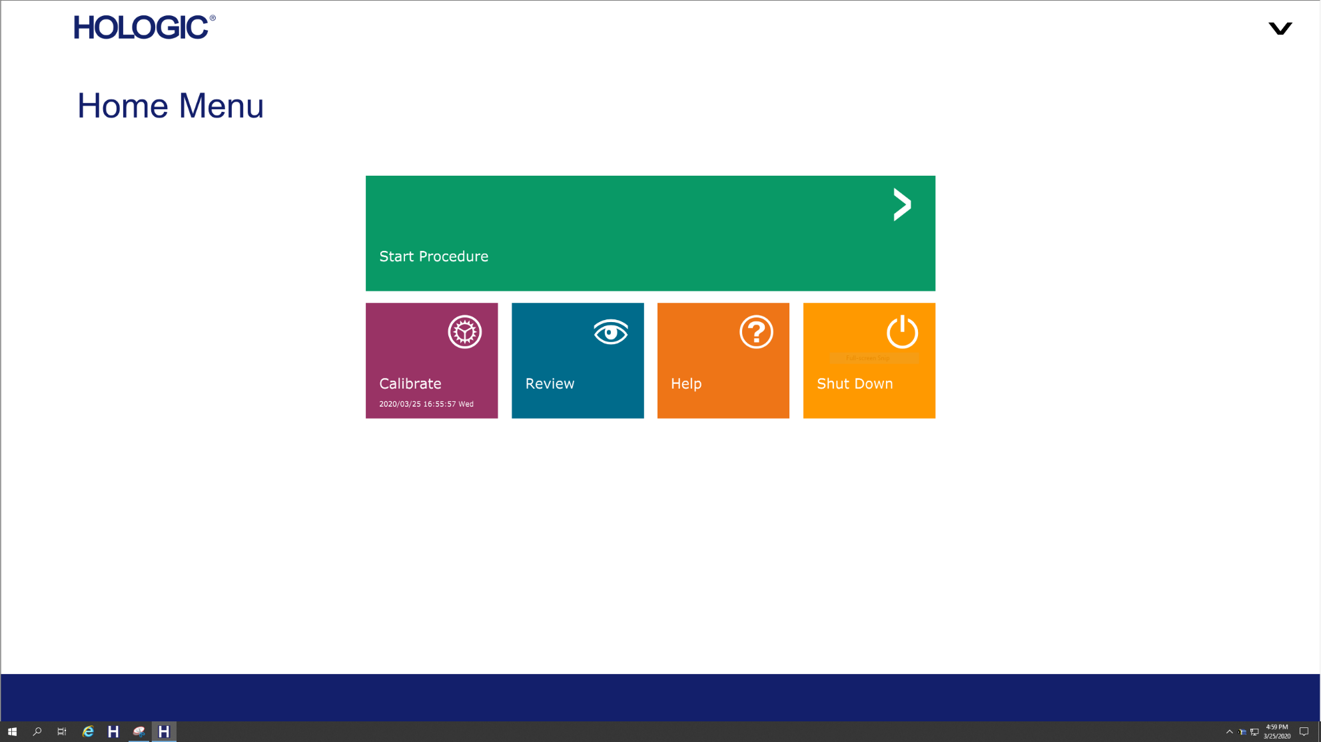

* Select **Manual Entry**.

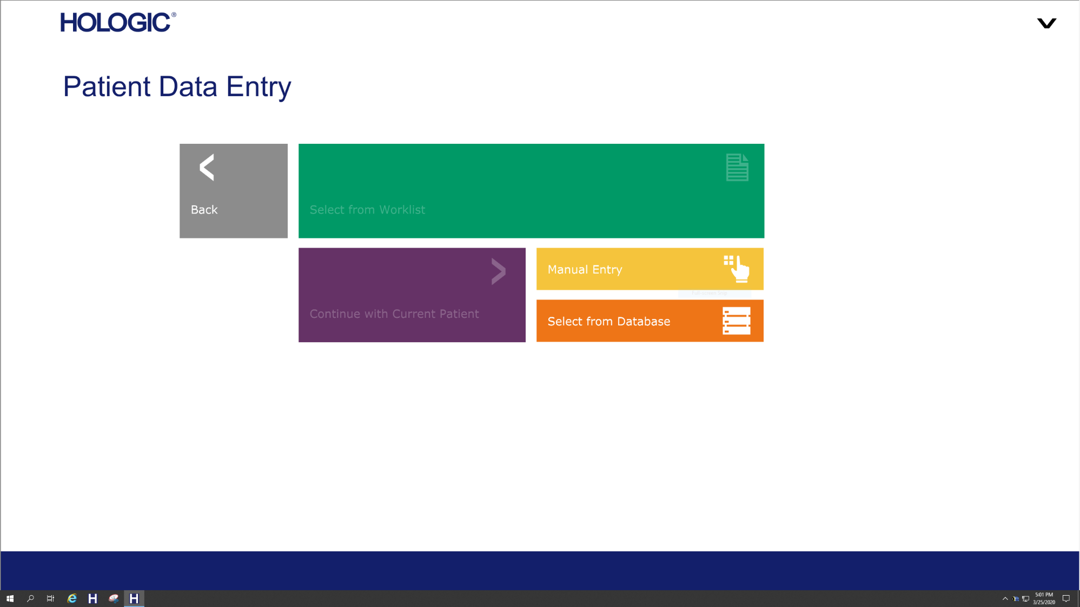

* Fill in the required fields (labeled with asterisks).

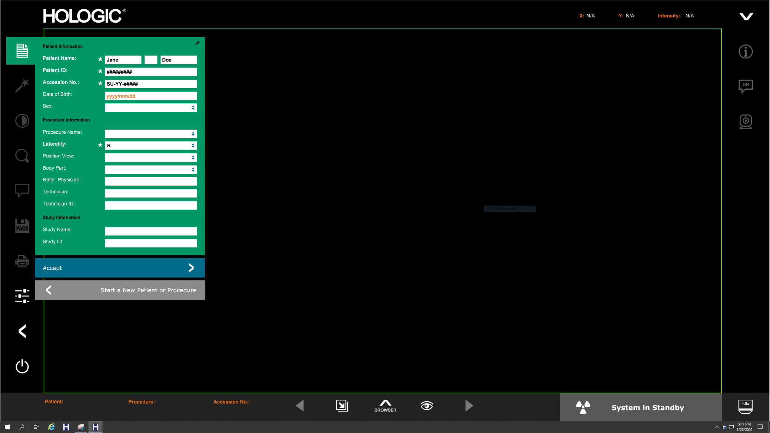

* Click **Accept**.

**X-Ray Imaging**

* Place specimen(s) in the Faxitron Path x-ray chamber—use magnification tray if desired.

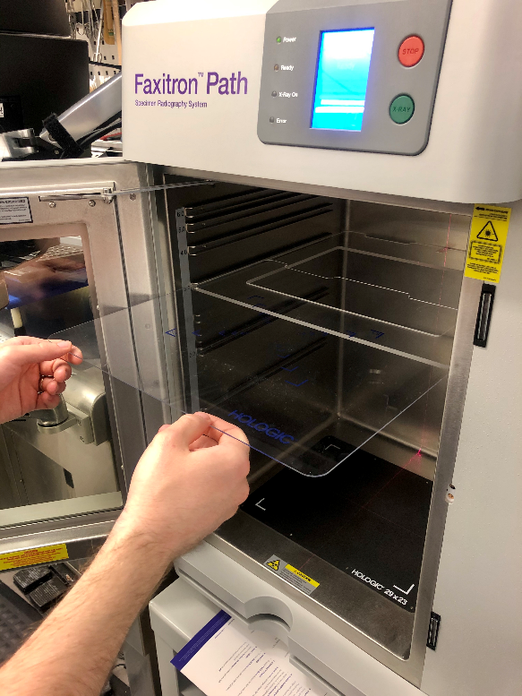

* Close the door completely.
* Select **Start X-Ray** (green button) to activate x-rays—an image will appear after a few seconds.

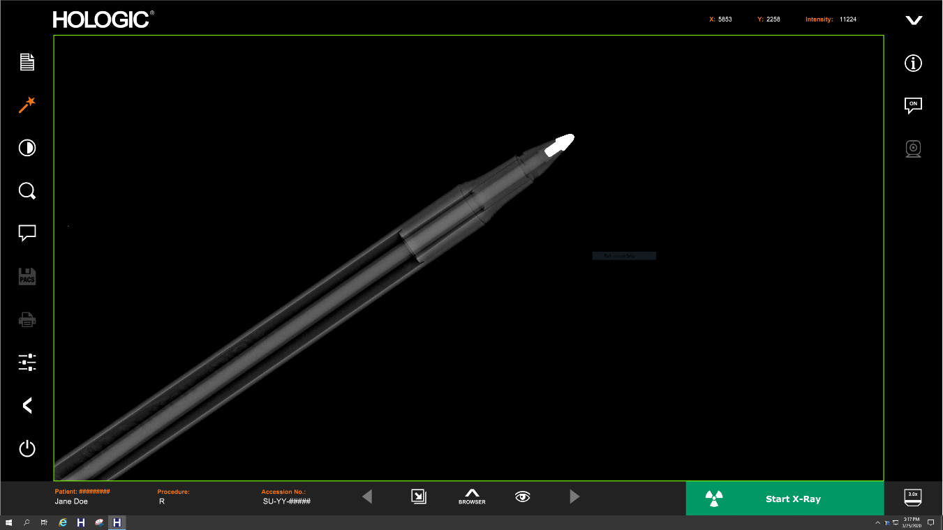

**Image Manipulation**

* Hold down the left mouse button and drag the mouse to change the brightness and contrast OR select the contrast button (located in the left toolbar above the magnifying glass) if you prefer using physical sliders.

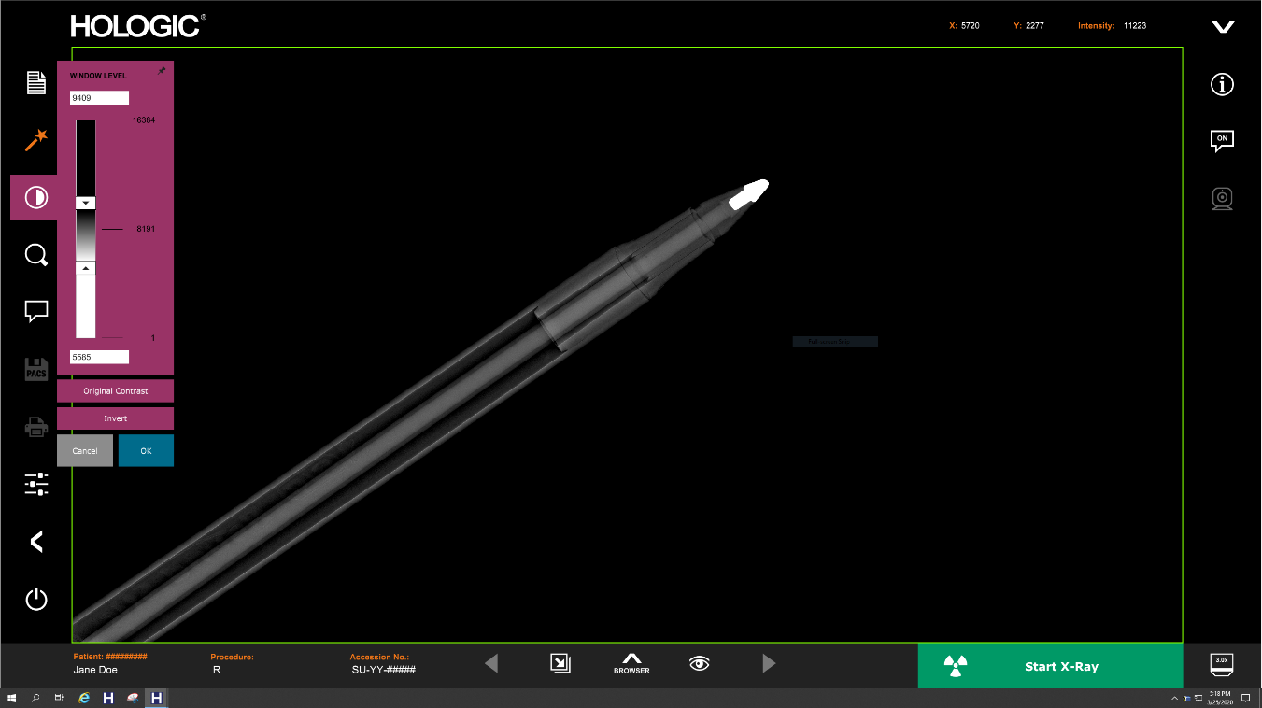

* Adjust zoom (magnifying glass in left toolbar) to enlarge image for viewing.

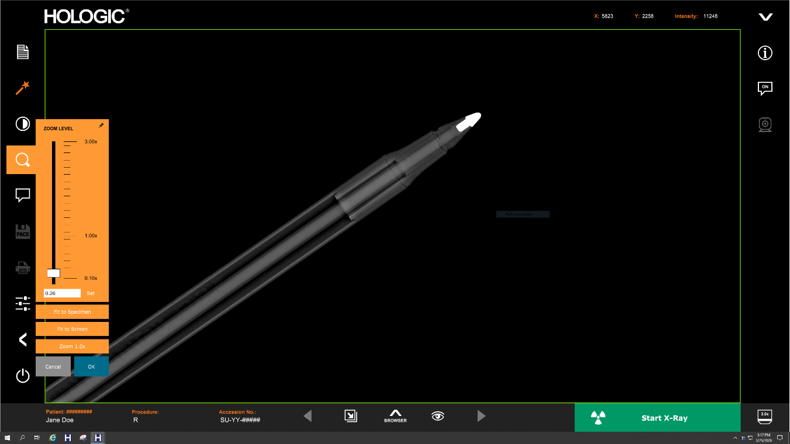

**Storing to PACS**

* Choose **PACS Store** button on left side of screen.

**Printing**

* Choose **PACS Print** button on left side of screen.

**Shutdown**

* Select the **System Shutdown** button on the left side and then click **OK**.
* Turnkey on Faxitron Path cabinet to **Off** position.

**Transferring Images to SOFTPATHDX**

1. In Specimen Processing: Select your order, click the scanned docs/images button in the toolbar

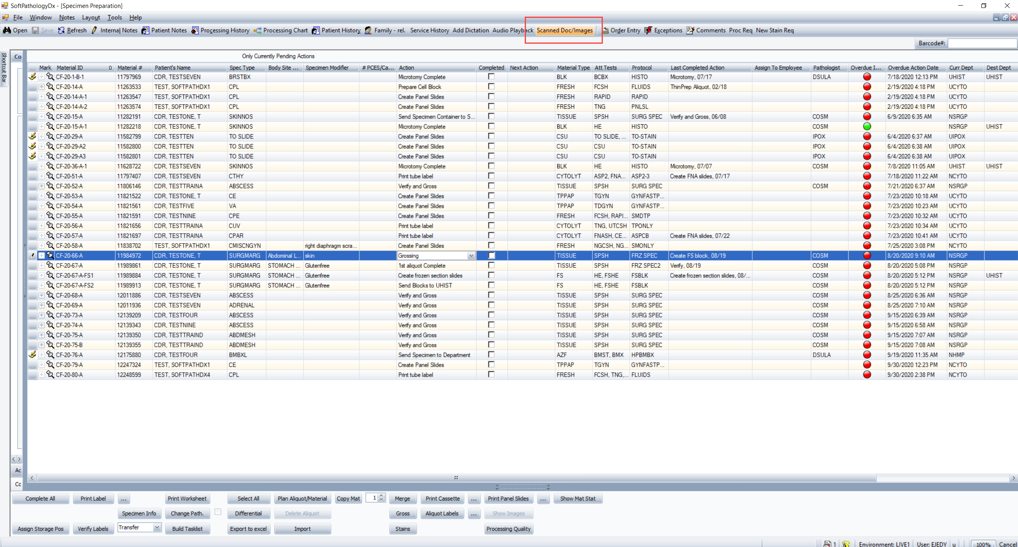

1. Click the “Add File” button

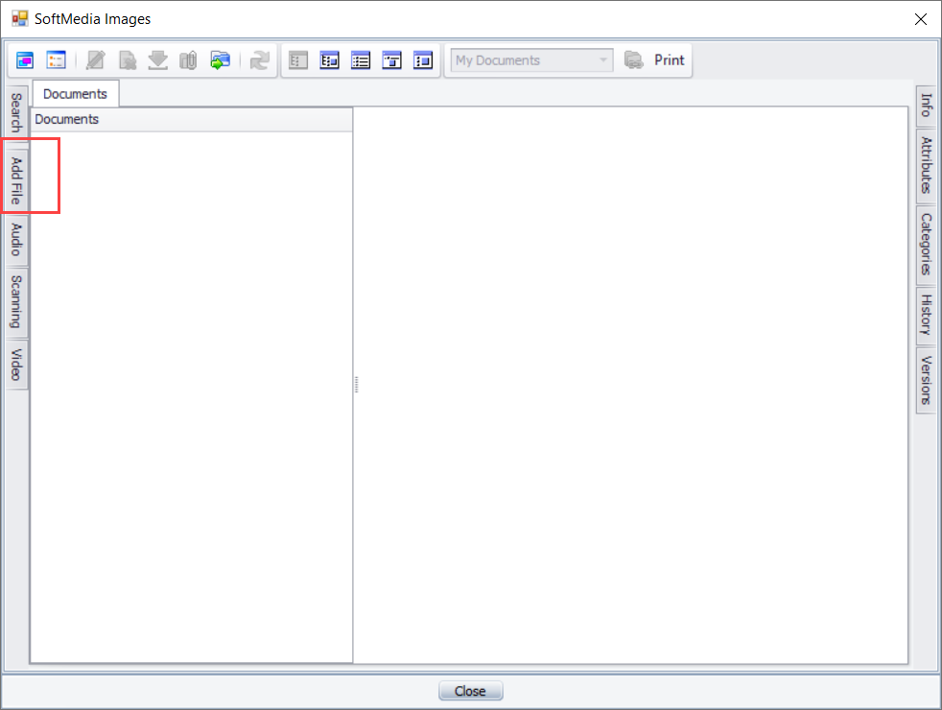

1. Click the file folder “Add File”.

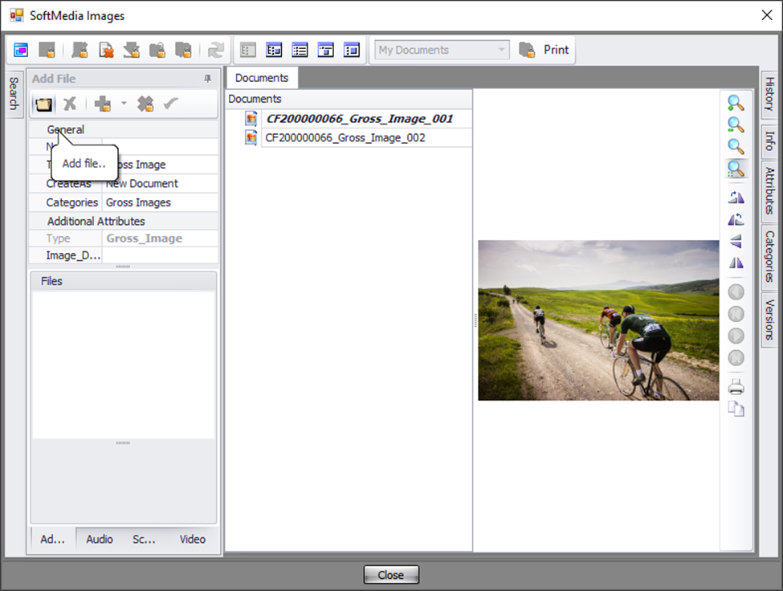

1. Navigate to the network drive where your images are: S Shared drive, Path_Groups, AP_Images, Faxitron_ Radiographic_Images and the SU number where your images reside. Select thumbnail or all relevant thumbnails. If transferring more than one file, press control (Ctrl) and select all thumbnails with mouse. Click Open.

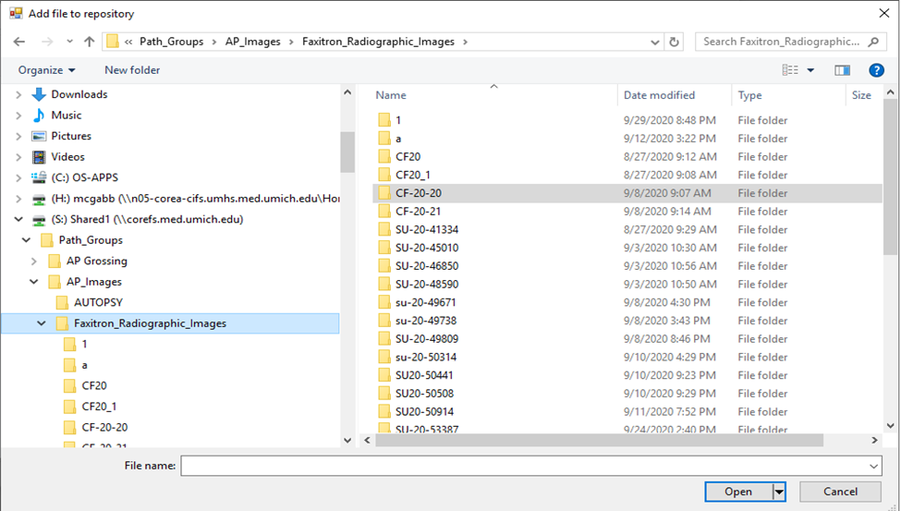

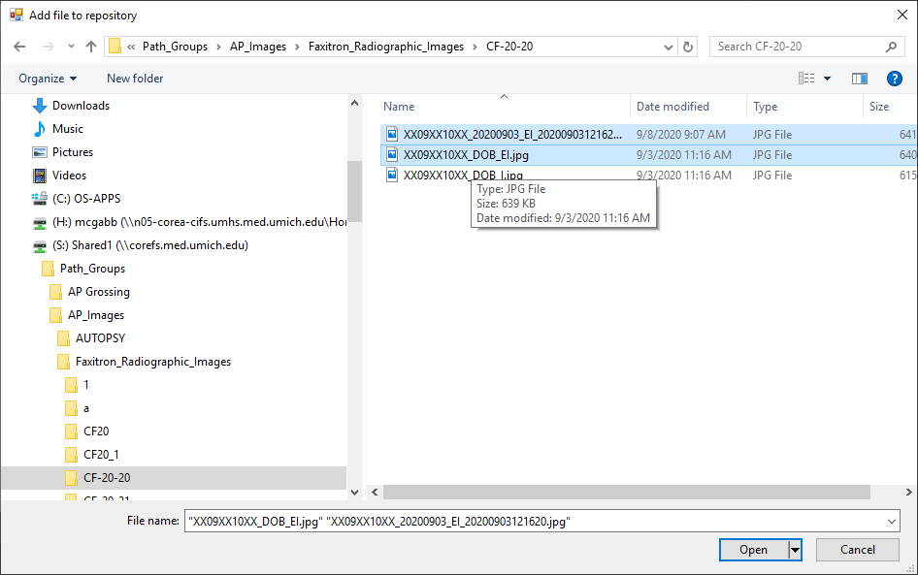

5. Double check all files are listed in the file box on the bottom left. Click green check box.

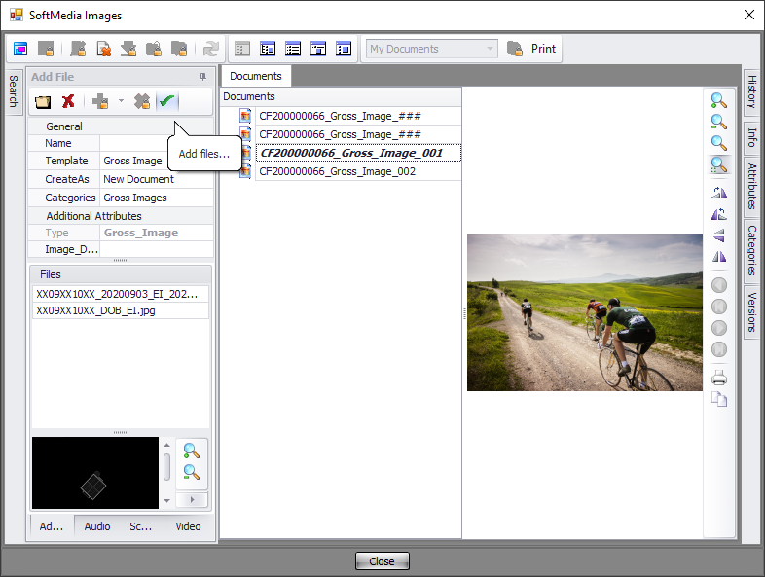

1. Click Close, then click Save in the Specimen Processing toolbar. Save will not be active until you close the images field.

